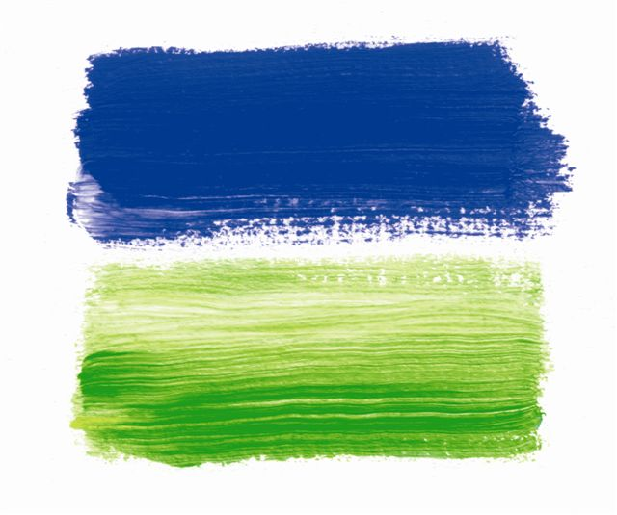

Raison d’Etre creates a ‘tented spa’ for The Serai

Raison d’Etre, top international spa development and management consultancy, has been working with SUJÁN Luxury Hotels to create a spa for The Serai in Jaisalmer that promises to be Rajasthan’s most luxurious tented camp when it opens in Autumn 2009.

Located just 30 minutes from the ‘Golden City’, The Serai features twenty-one luxurious canvas tents that are divided into three categories: Tented Suites with their own private veranda, drawing room, extremely spacious bedroom and en-suite bathroom; Luxury Tented Suites with an additional private walled garden and a plunge pool; and the Royal Tent that also boasts a private spa, pool and lounge tents.

Inspired by the panoramic vistas of the great Thar Desert, Raison d’Etre has created a spa that features four treatment tents set apart from the main camp, allowing total privacy and tranquillity - only a thin layer of canvas divides the guest them from the tranquillity of this magnificent desert. Each spa tent is split into three parts - the welcome area where guests will receive a drink and meet their therapist, the changing area, and a large treatment room. Locally-sourced stone, canvas, and white and indigo colour schemes have been used throughout the spa. All the tents are air-conditioned in the summer and heated in the winter.

Raison d’Etre’s commitment to creating unique spa experiences is also evident in their choice of products which have been created exclusively for The Serai. Plants, herbs and spices from the Rajasthani environs have been blended together to offer guests a totally natural product that is both uplifting and healing. The spa menu offers a variety of treatments designed to alight and restore the body clock with the more mystical rhythms of Rajasthan. Some of the treatments include:

Serai Massage
There is an art to navigating the sand dunes of Jaisalmer. It requires a knowledge that comes from sharing an intimacy with the desert and understanding of its temperament. This is the same with a massage and Raison d’Etre’s trained therapists’ hands will traverse your body as if they knew its secrets. An exclusively designed Serai Massage Oil which blends Tulsi, Basil, Saffron, Honey and Black Sesame base is used in this soporific treatment.

Scrub & Wrap
The serenity of the desert stems from its environmental extremes. The soul is the benefactor if its peace, while the skin plays victim to its climate. This treatment restores the skin so that your outer radiance can reflect your inner glow.

For more information on Raison d’Etre please visit their website www.raisondetrespas.com

***Ends***

For further press information, press pack or to arrange an interview with a Raison d’Etre representative, please contact Melanie Cutcliffe or Elena Black at Indigo PRCo on Tel: 020 7259 1140 or email: firstnameinitialsurname@indigoprco.com

Notes to Editor
Raison d’Etre is the leading spa company creating tailor-made spas from concept to development and through to opening, training & ongoing management. They have set up over 50 spas in 25 countries worldwide and all of them are holistic and designed to provide a restoring and healing environment in which lives could be changed through the gift of self-discovery.

